**2100090166  
J.KASAIAH**

**.NET PROGRAMS**

**HOME ASSIGNMENT-02**

List of practice programs on OOP concepts:

1. Access Modifiers(public,private,protected,internal)

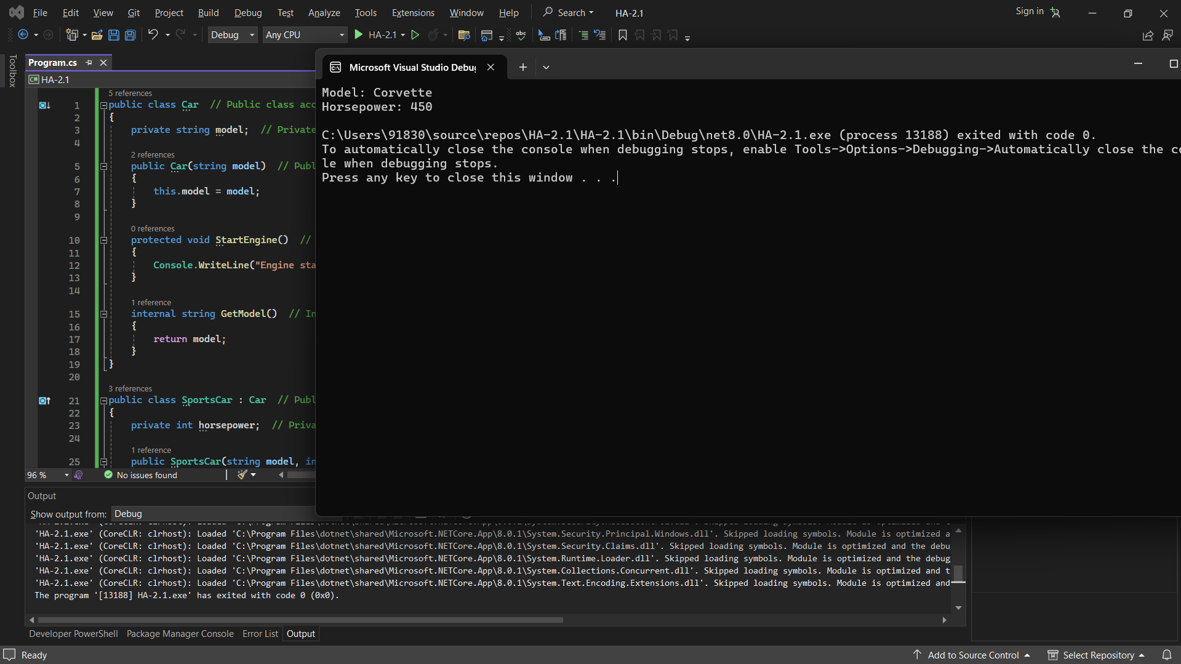

1. Use of set and get accessors

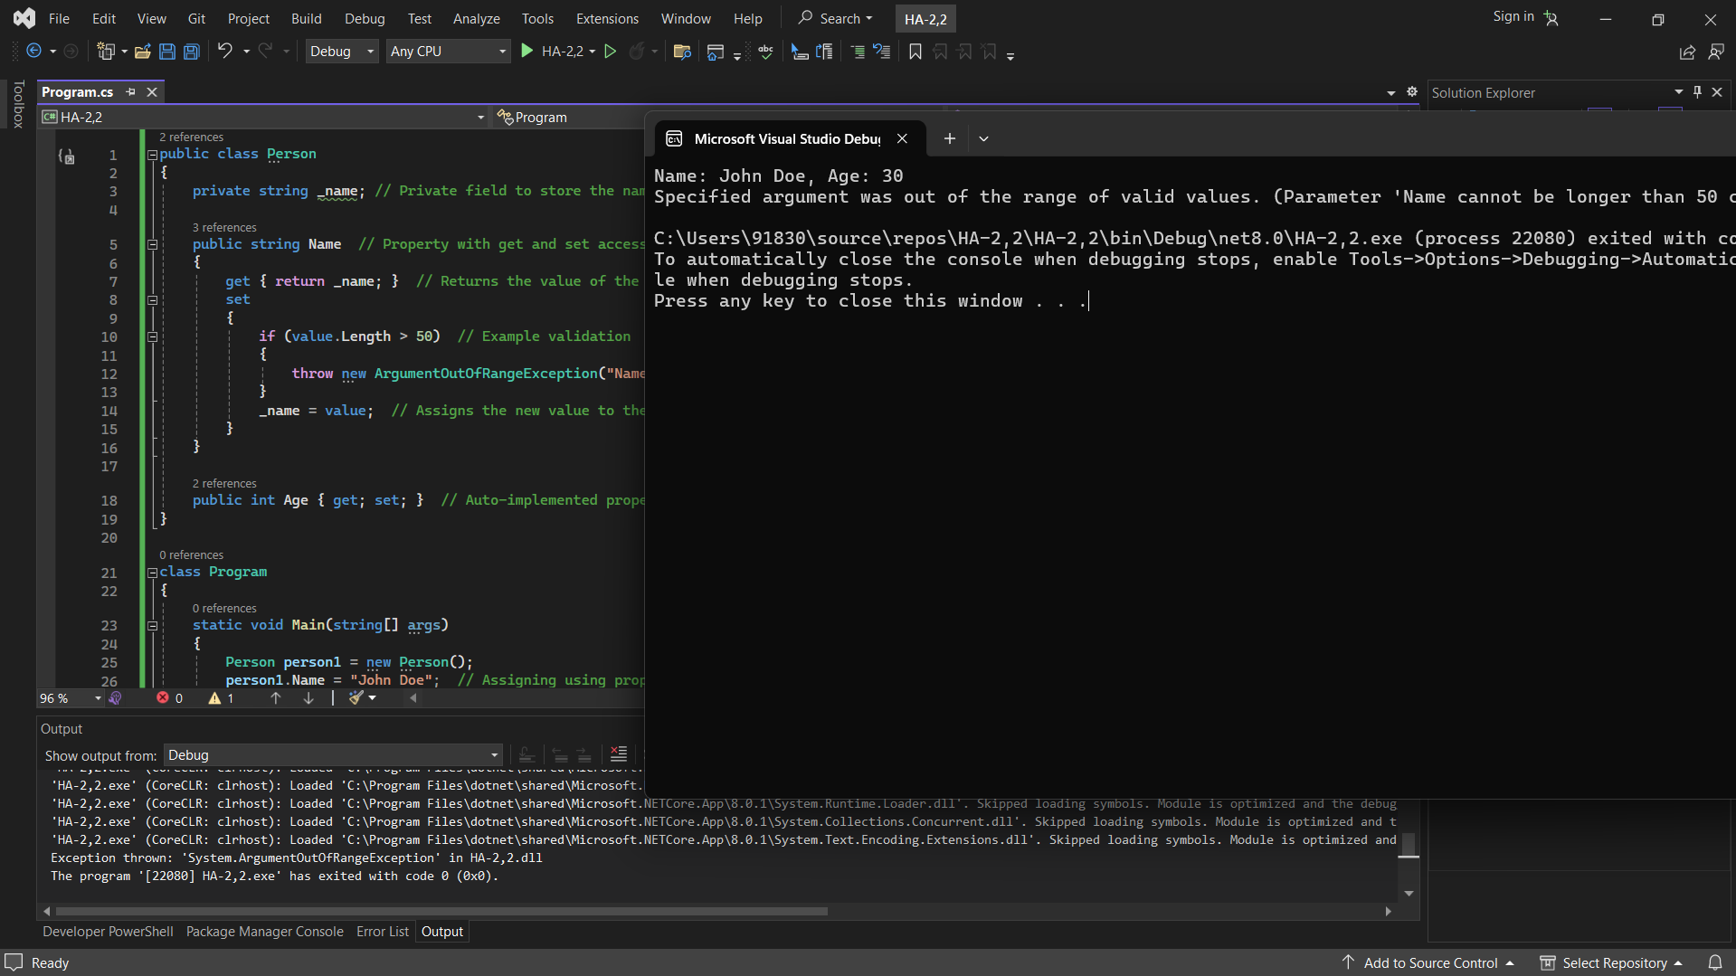

1. Encapsulation and Abstraction

1. Inheritance

1. Polymorphism(compile-time,run-time)

1. Virtual ,override keywords

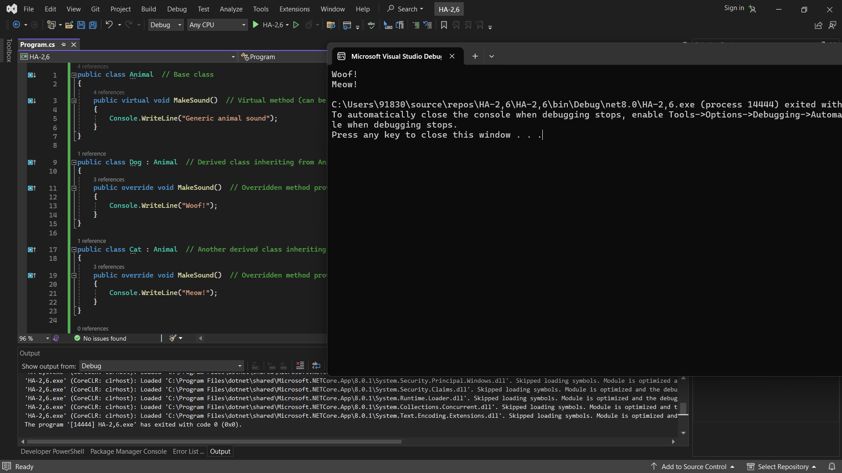

1. Constructors-destructors

